
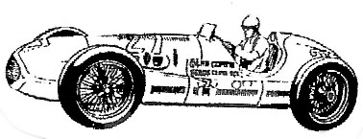
®
THE DAY BEFORE THE 500 SHOW
SATURDAY MAY 26 2012 9 TO 5
THE INDIANAPOLIS MOTOR SPEEDWAY® PAGODA PLAZA PAVILION
E X H I B I T O R A P P L I C A T I O N
EIGHT FOOT TABLES: $120.00 EACH - $110.00 IF YOU SUPPLY YOUR OWN TABLES
LIMITED NUMBER OF TABLES. WE EXPECT AN EARLY SELL OUT. MAIL PROMPTLY !
PLEASE RESERVE _____ TABLES AT THE INDY® MOTORSPORTS MEMORABILIA EXPERIENCE. I HAVE ENCLOSED A PERSONAL CHECK, CASHIERS CHECK OR MONEY ORDER PAYABLE TO: IMME FOR THE AMOUNT OF $________. SEND TO - IMME BOX 24594 SPEEDWAY, IN 46224 ASAP

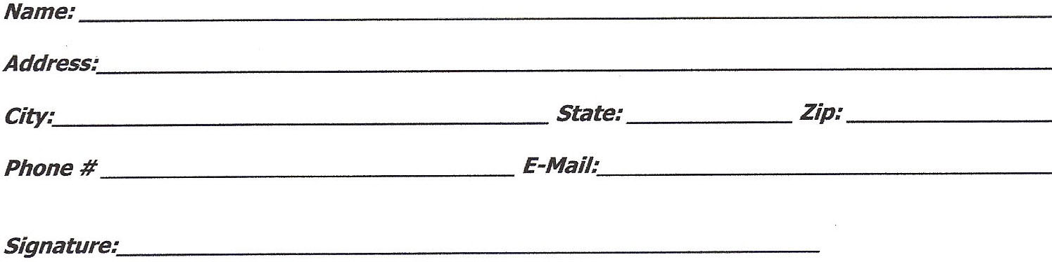
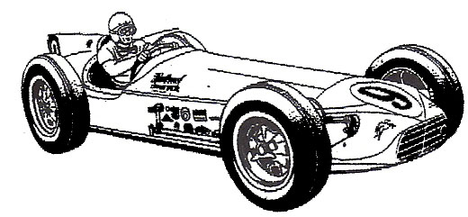
For additional table information contact:
Bill DeLong: Melindabill@att.net
John Darlington: dar500@indy.rr.com
Ted Knorr: ted-cathy@comcast.net

SAME GREAT SHOW ! SAME GREAT LOCATION !
Trademarks of Brickyard Trademarks, Inc. are used with permission.

